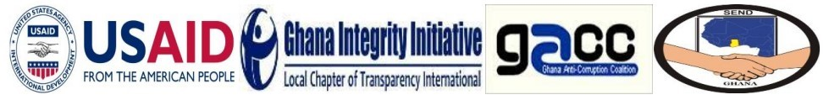****

**PRESS RELEASE!!!**

**THE RIGHT TO INFORMATION (RTI) ACTION CAMPAIGN GROUP**

Today is DAY 9 of the 10-day Countdown that was initiated as part of the coordinated Campaign for the speedy passage of the RTI Bill into law in 2018.

By this statement, the RTI Coalition and the RTI Action Campaign Group is reminding H.E President Nana Addo Dankwa Akufo-Addo of his 6th March pledge to have the near two decades old RTI Bill laid and passed before Parliament rises. Parliament goes on recess tomorrow March 23, 2018. While we accept that the Bill cannot be passed immediately, **at the minimum we expect the bill to be laid in Parliament before it goes on recess**, **tomorrow.**

We are united in our belief that passage of the RTI Bill is necessary to make credible and effective existing anticorruption legislation, including the Office of the Special Prosecutor Act and the Whistleblower Act. Similarly, we are confident the passage of the RTI Bill will help address the public financial management and institutional weaknesses noted in the recently concluded Auditor General report on the liabilities of Ministries, Department and Agencies ending 31st December 2016.

It is in the interest of the citizens of Ghana and for the urgent need to give meaning to the article 21 “Right to Information” and the article 41 citizens duty “to protect and preserve public property and expose and combat misuse and waste of public funds and property”, for him to keep this promise.

We are unable to find any reasonable justification for the continued inaction on the RTI Bill and hereby call on H.E. President Nana Addo Dankwa Akufo-Addo and his government, to ensure that the RTI Bill, is laid in Parliament tomorrow. The time for talking is over. If we mean business, then we must act.

The RTI Coalition and the RTI Action Campaign Group calls on the media fraternity to continue with their support of this campaign and on citizens to join the campaign for the passage of the RTI Bill.

God Bless Ghana!

Thank you.

***#PassTheRTIBillNow***

**ACCRA, MARCH 22, 2018**